AWS ASSIGNMENT DAY 3 AND 4 05/10/2020:

PROJECT 1:
Deploy a web server in Windows instance.
Task 1: Create a windows Instance using AMI: Windows 2012 R2 base
Task 2: Launch the Windows instance using RDP
Task 3: Install IIS web Server using PowerShell ISE
NOTE: Simply copy the command below and paste In the PowerShell ISE to install the IIS web server.
PowerShell Case sensitive.
Install-WindowsFeature -name Web-Server -IncludeManagementTools

Task 4: Verify successful installation of IIS Web Server
Note: You should be able to see the Internet Information Services Web page When you paste the IP into the browser.
- Below is the screenshot of the windows instance created.

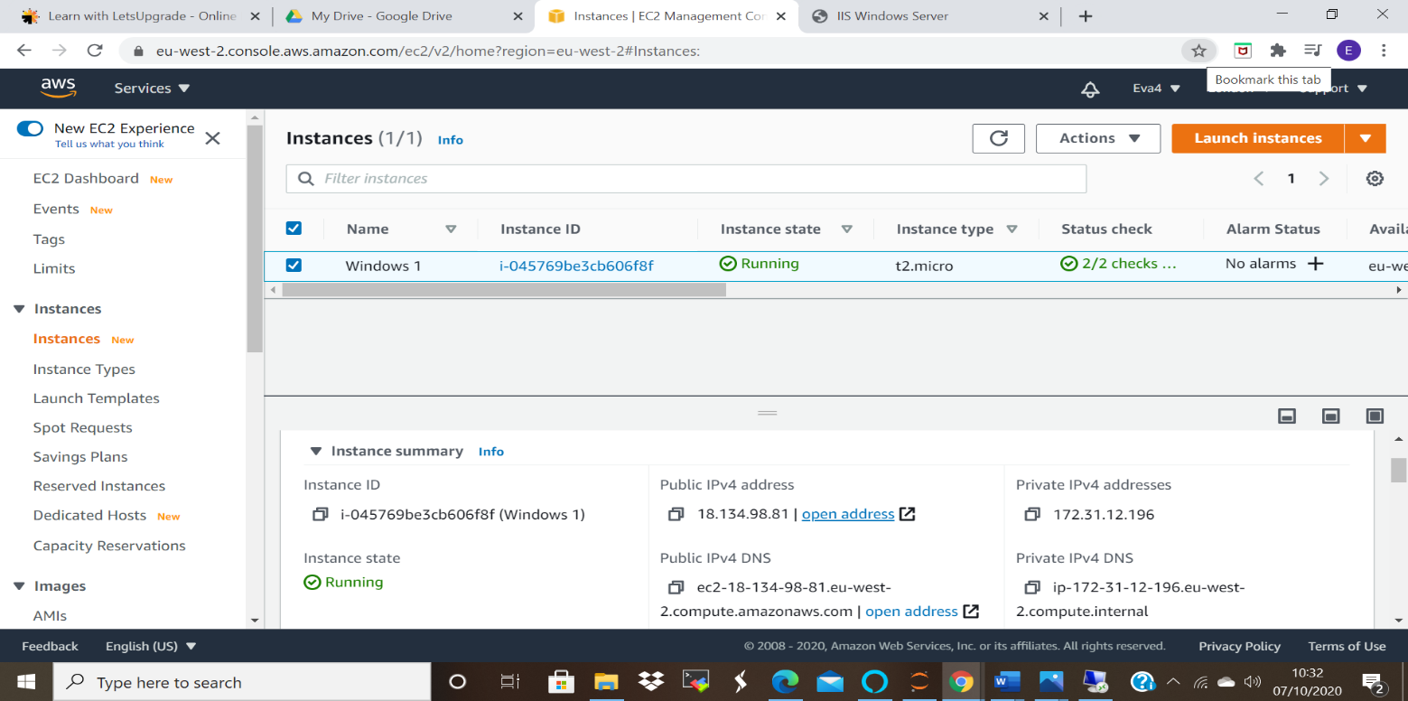
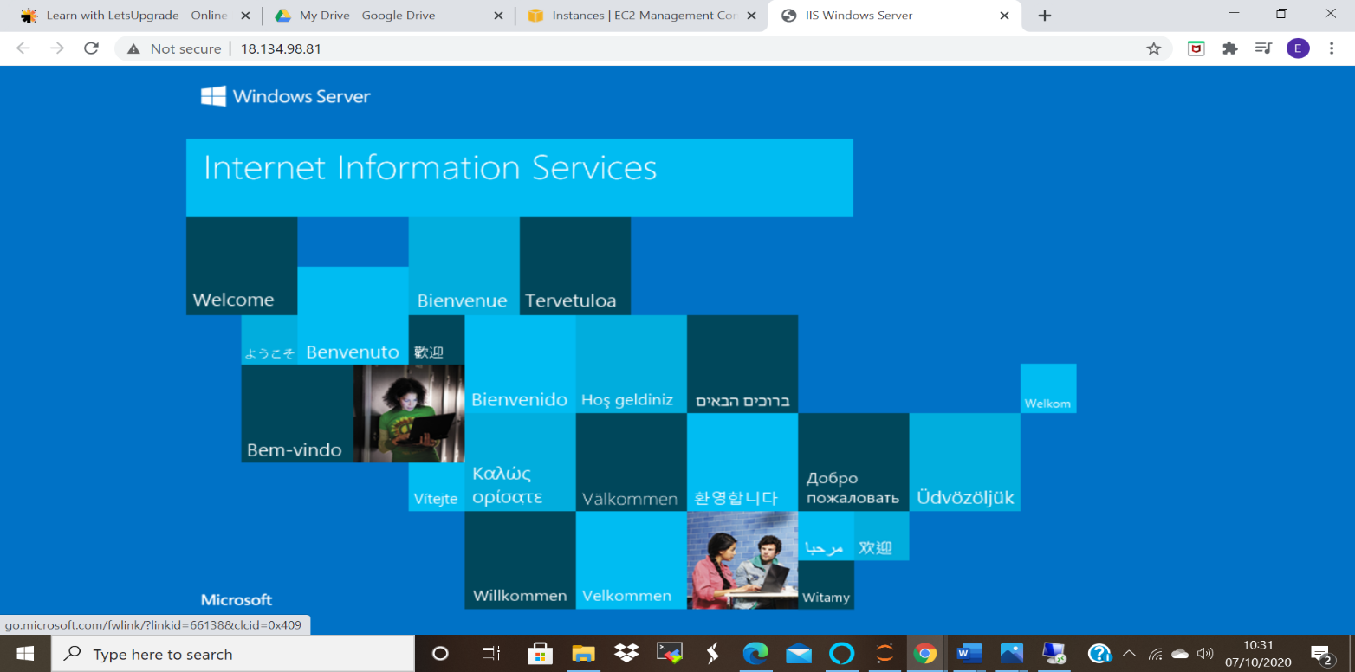

PROJECT 2:
Deploying a web server in Windows instance
Task 1: Create a windows instance using AMI: Ubuntu Server 18.04 LTS (HVM).
Task 2: Launch the Ubuntu instance.
Note: Username is ubuntu
Task 3: Install Nginx webserver using bash Note:
Simply copy the command below and paste in the bash to install the Nginx webserver.
sudo apt-get -y update
sudo apt-get -y install nginx
Task 4: Verify successful installation of ngnix
Note: You should be able to see the Welcome to ngnix Web page when you paste the public IP into the browser.

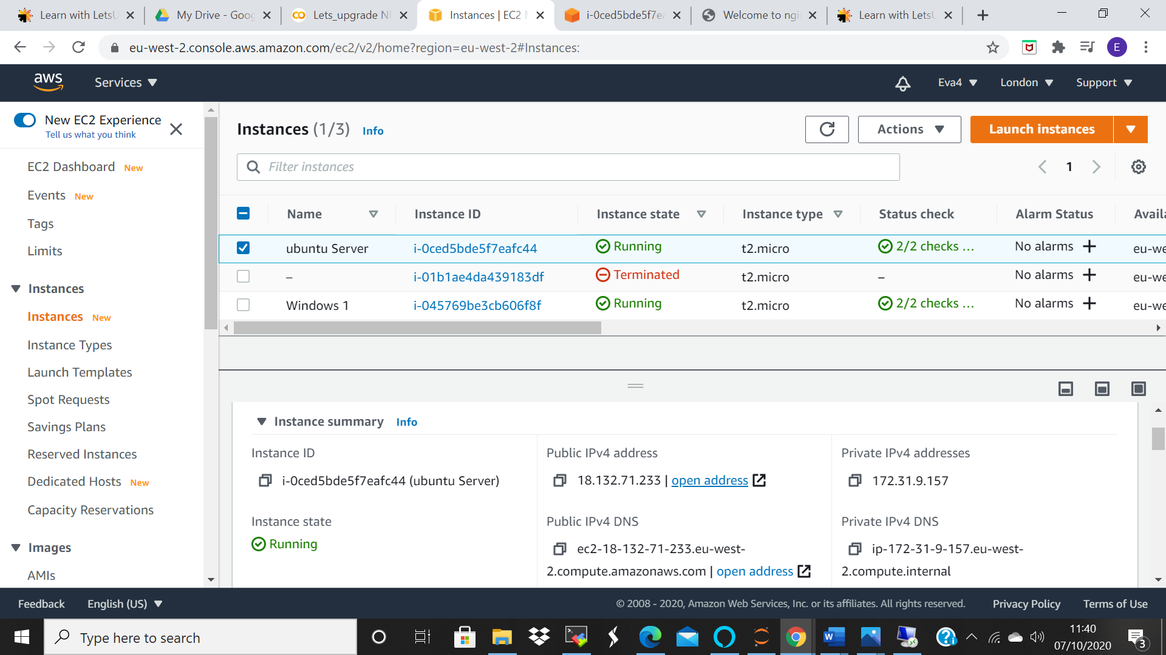

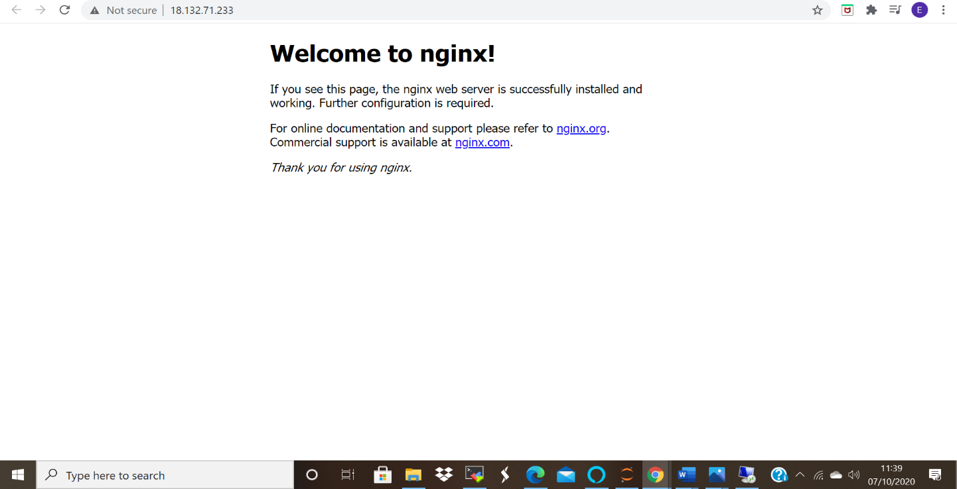

PROJECT 3:
Working with volumes
1: Create a windows machine
2: Create a volume in the same region as the windows machine
3: Attach the volume to the windows machine
4: From server manager bring the volume online
5: Once the EBS is online create a new volume
6: Check if the volume is mounted successfully
7: Try modifying the volume config
8: Delete the volume

Below are the pictures of the created Ebs volumes
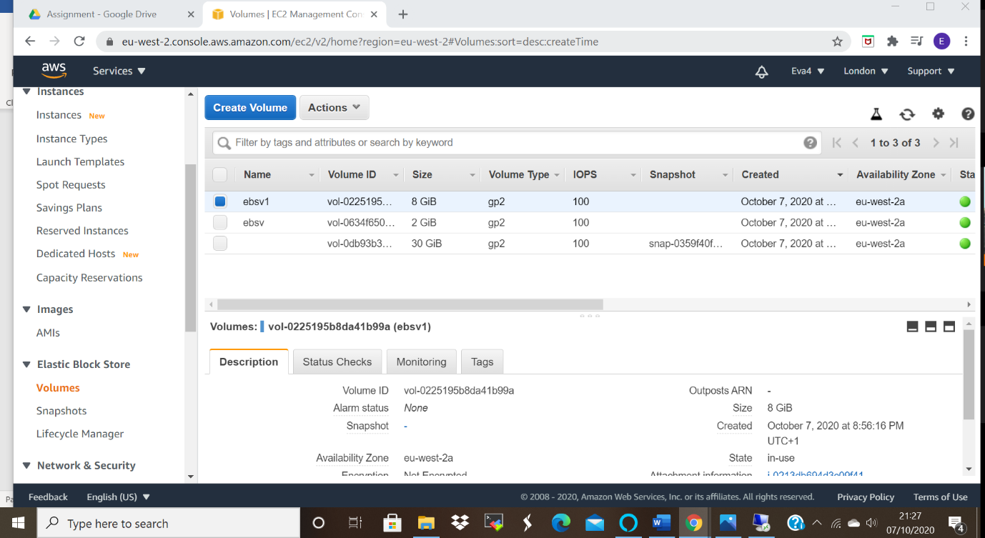

Confirmation of the attachment of the ebs volumes to the windows instance.
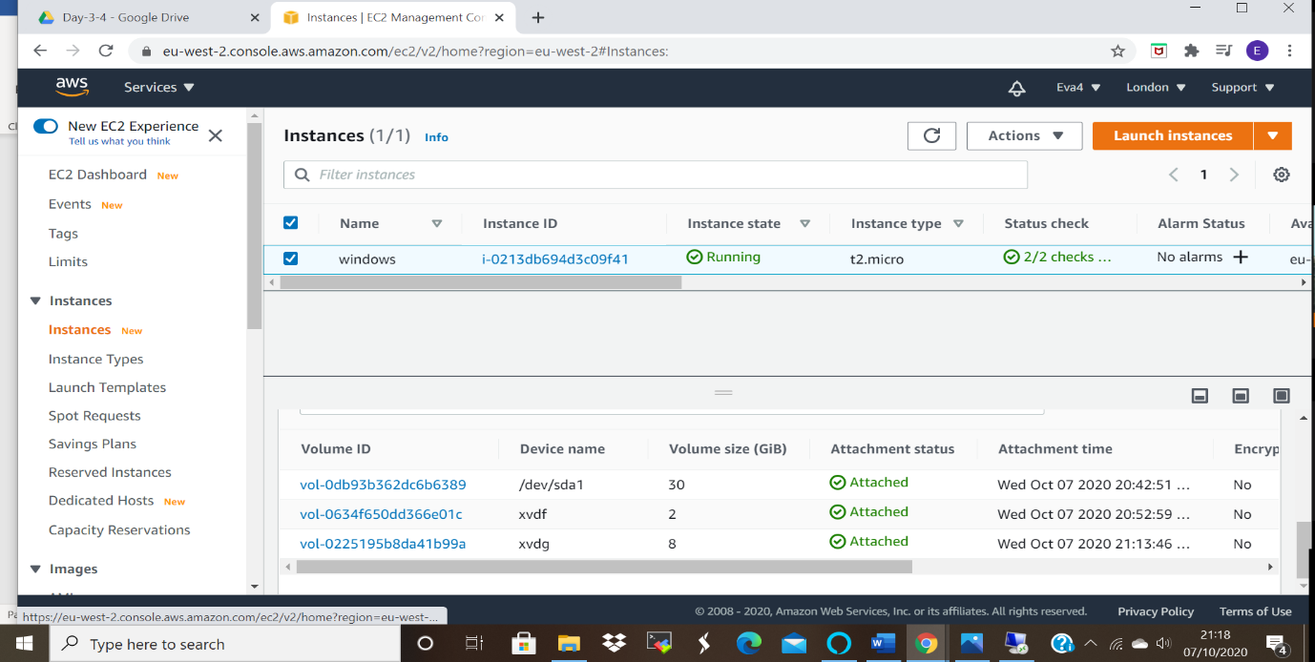

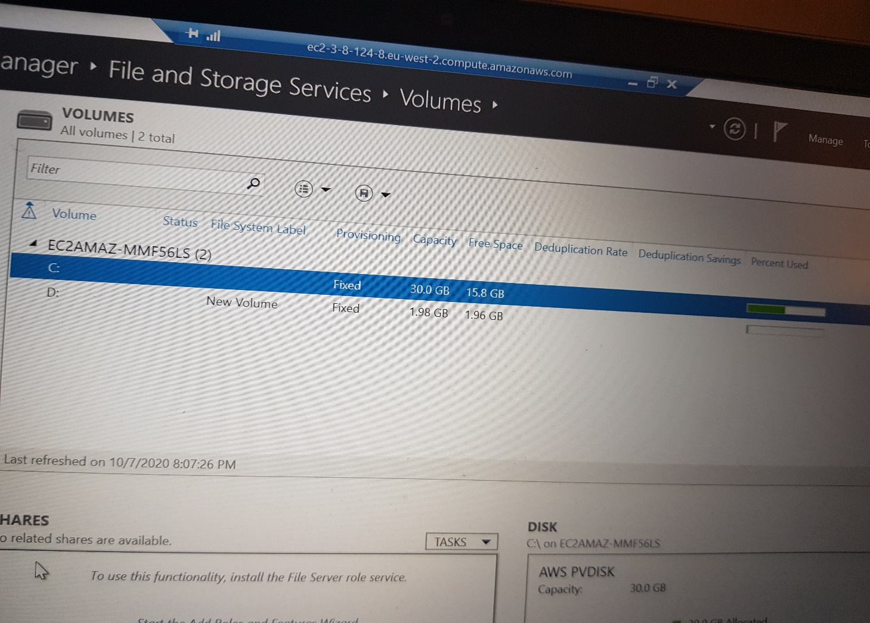
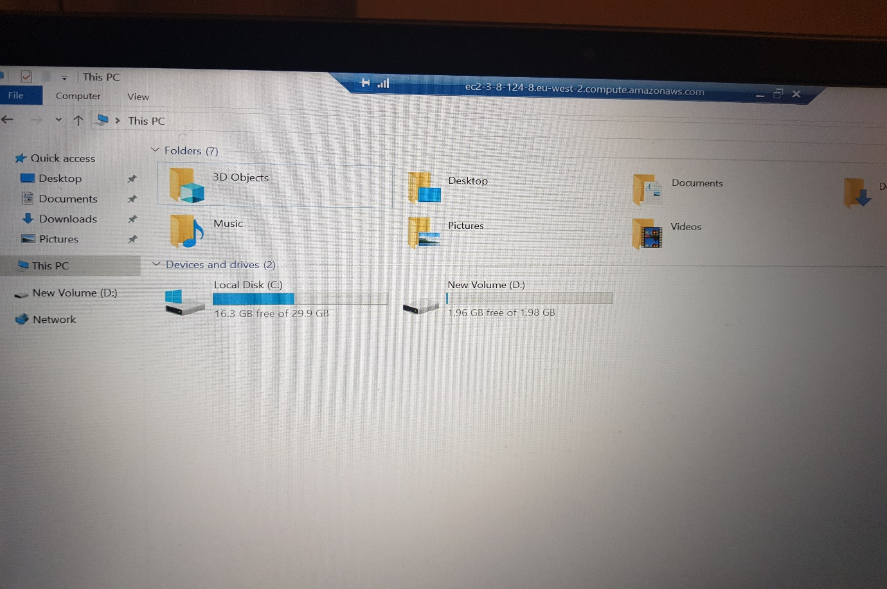
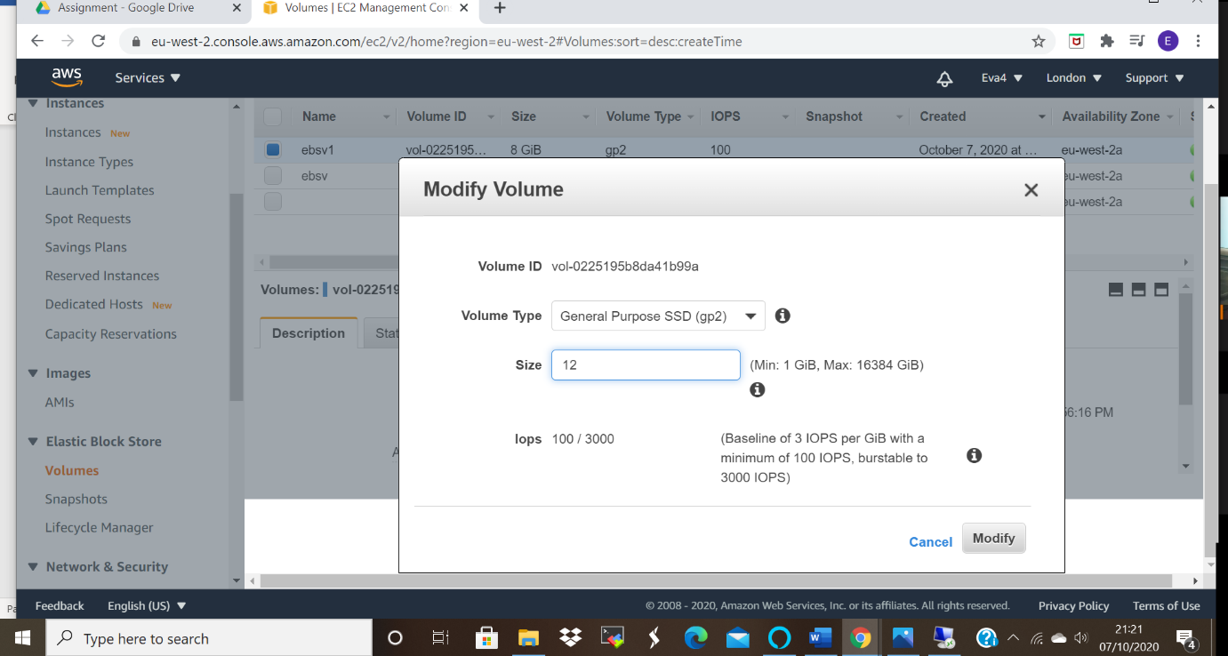
Snapshot picture
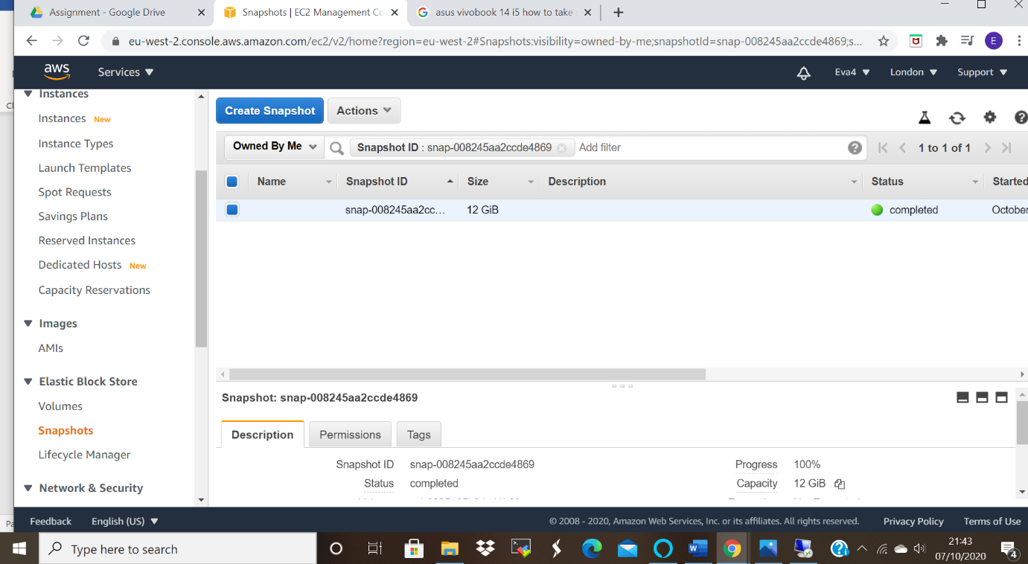
- The picture below shows that only the second ebs has been deleted.
- You can only delete the added volumes after you detach them from the instance.
- Even after terminating the instance only the volume created when an instance is launched will be delete, the added volumes will still be running.
- Ensure you terminate them manually.
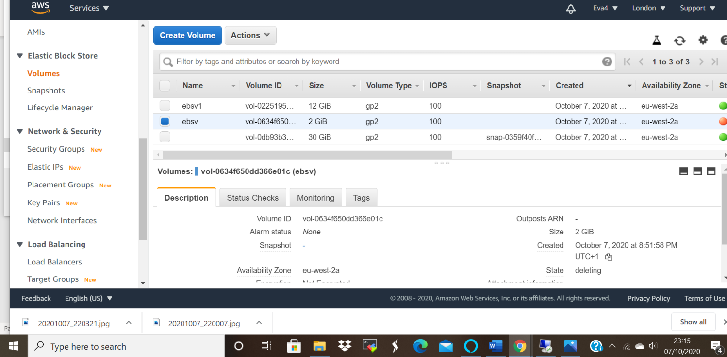

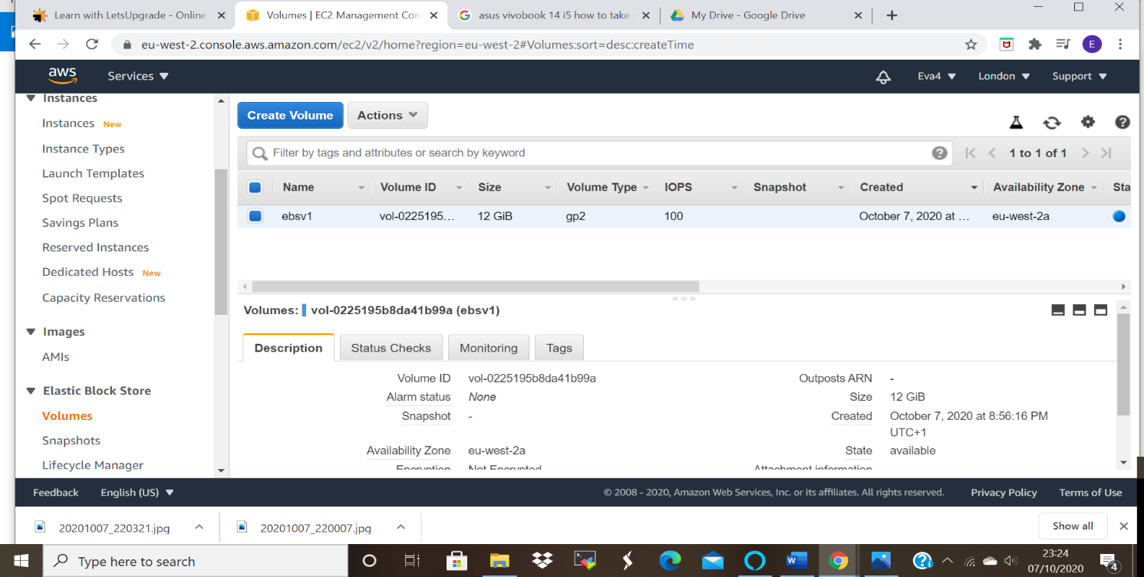

After termination of the instance I was able to manually delete the above ebs volume.

PROJECT 4:
Working with Elastic IP's
Step1: Install an Apache Server
Switch to the root user
sudo -s
Step2: Now run the updates using the following command:
yum -y update
Step3: Once completed, lets install and run an apache server
Step1: Install the Apache webserver:
yum install httpd
When prompted, press "Y" to confirm.
Step2: Start the webserver
systemctl start httpd

Step3: Now enable httpd:
systemctl enable httpd
Step4: Check the web server status
systemctl status httpd
- You can see the active status is running.
- You can test that your web server is professionally installed and started by entering the public IP address of
- your EC2 instance in the address bar of a web browser. If your web server is running you will see the
- Apache test page. If you do not see the Apache test page, then verify whether you followed the above steps
- properly and check your inbound rules for the security group that you created.
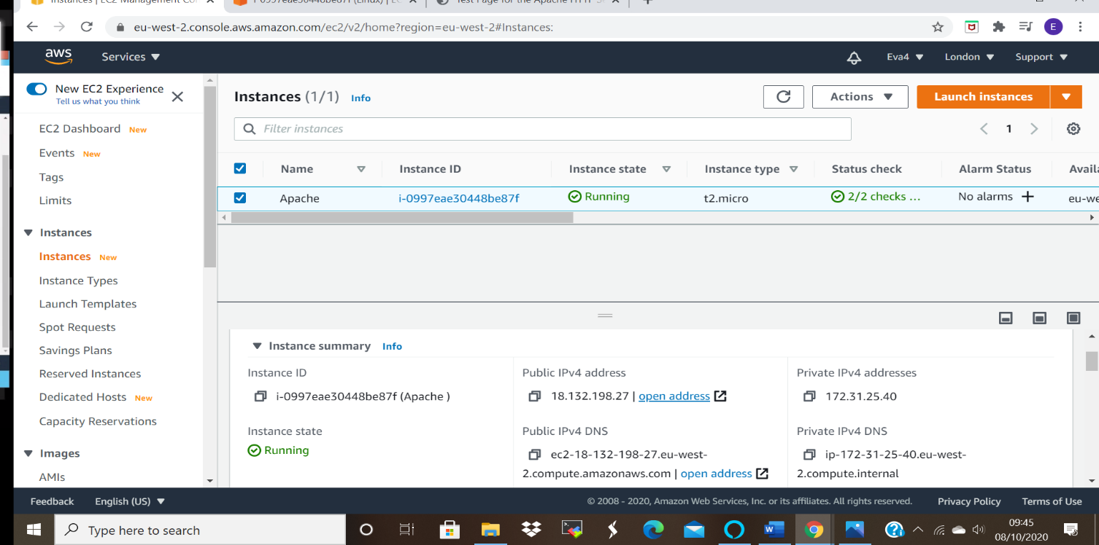
The picture is a confirmation of successful installation of the Apache server

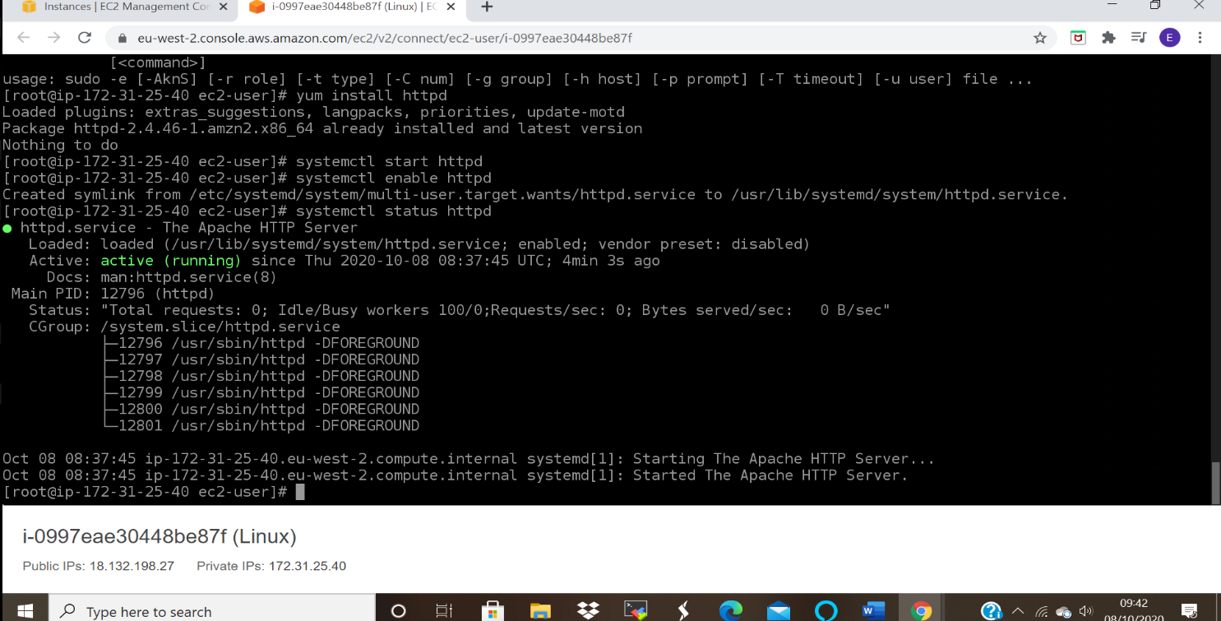

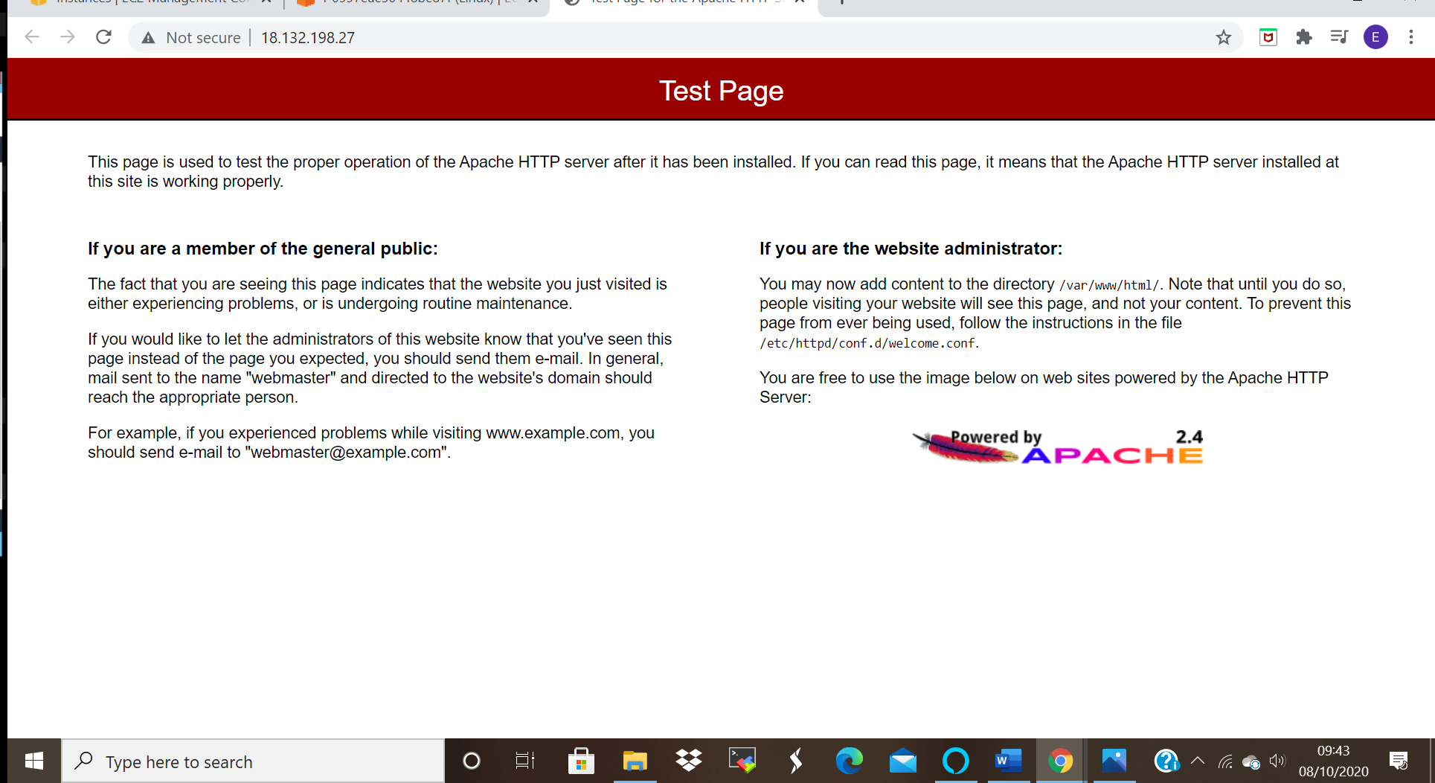

Elastic IP Address:
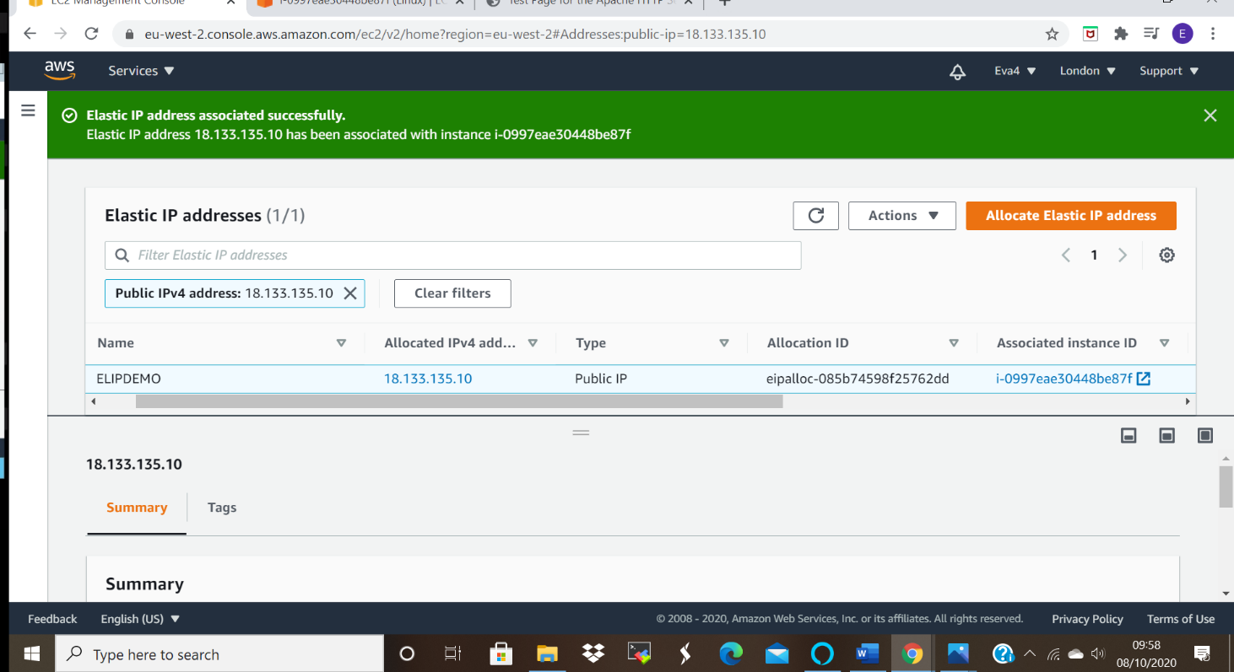
- After Association of Elastic IP with the instance when you refresh the Apache test page, it will not show the page until we make use of the new IP address .
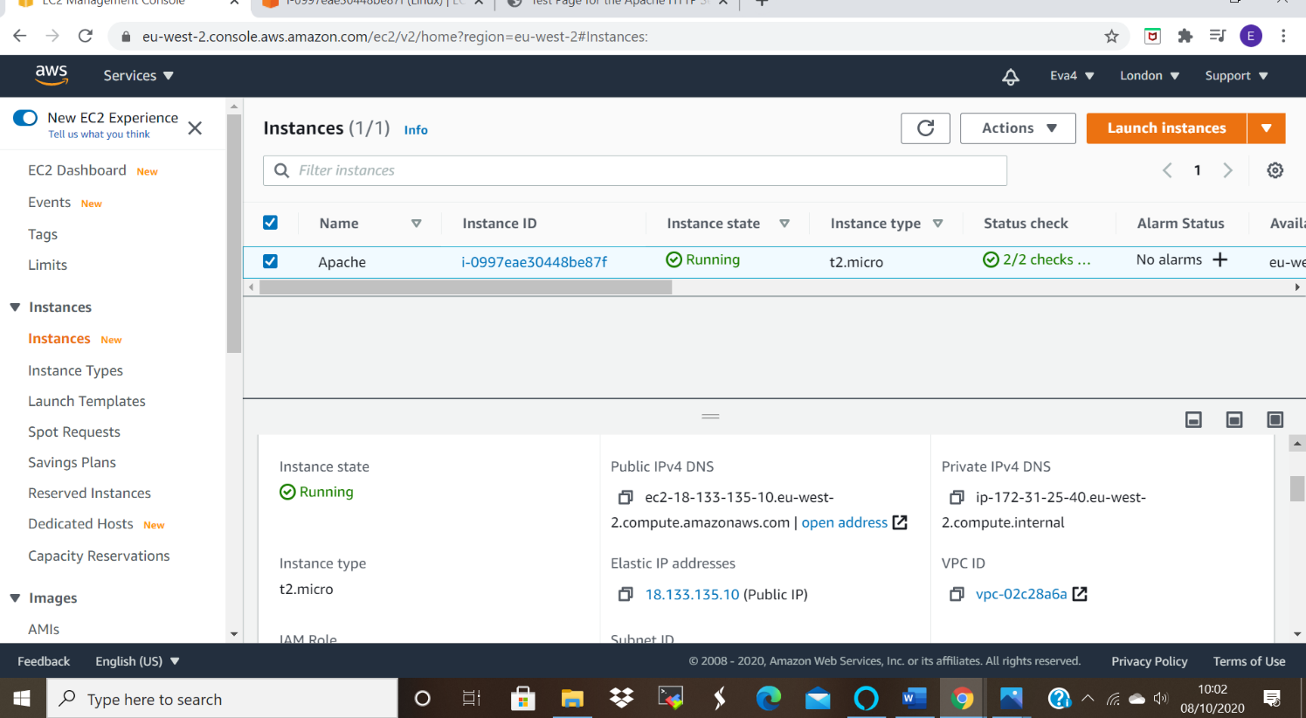

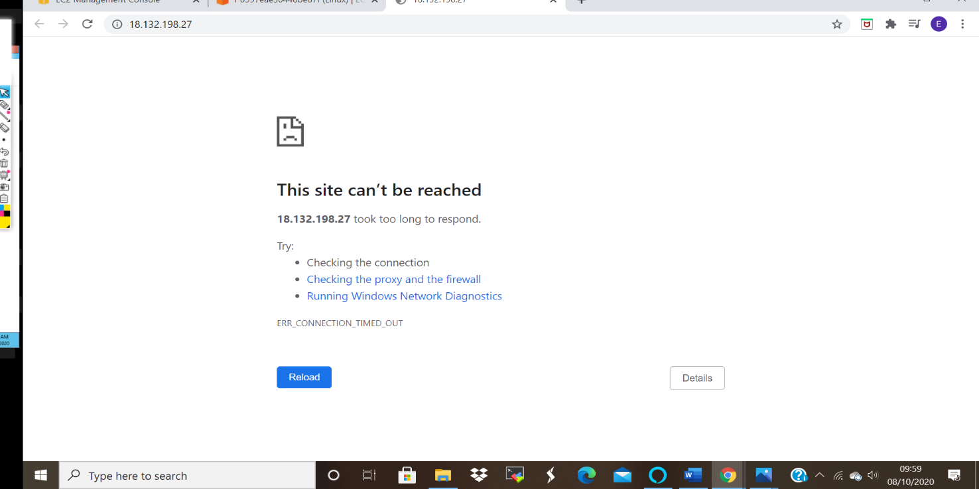

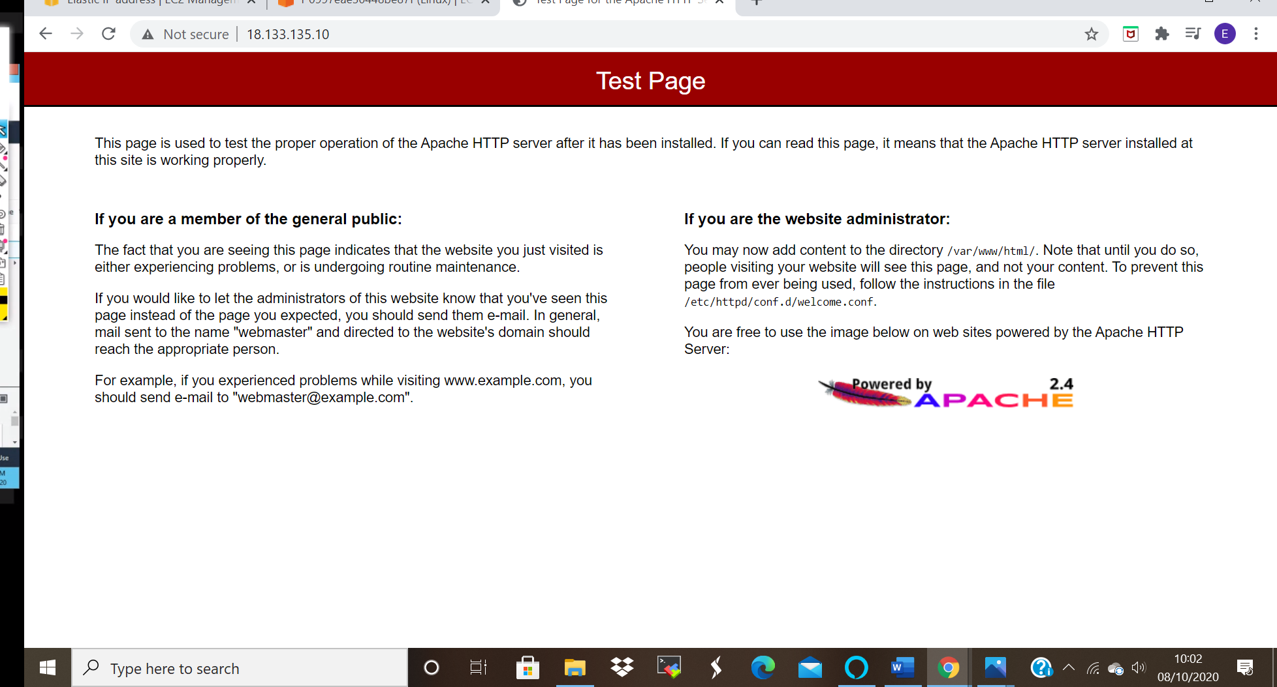

PROJECT 5:
Working with S3
a. Working with S3-.jpg
b. Static web hosting
c. Versioning
- In order to work with S3 storage,
- Create a bucket. Give it a name.
- Upload a file.
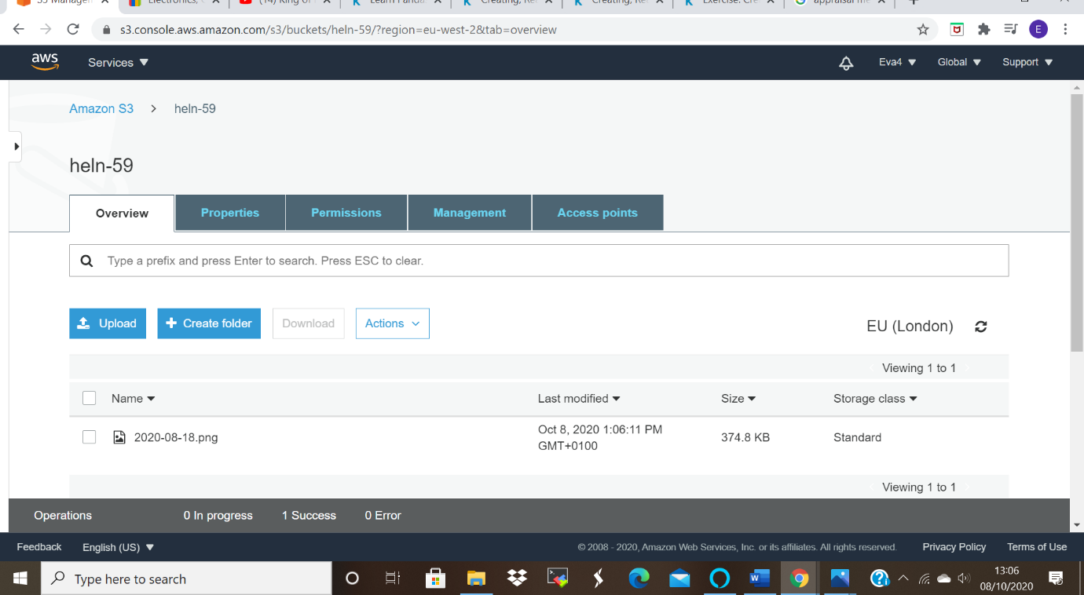

- Open the file and copy the url and paste on the browser.
- The access denied page shows. Which means that by default the contects of the file is private.
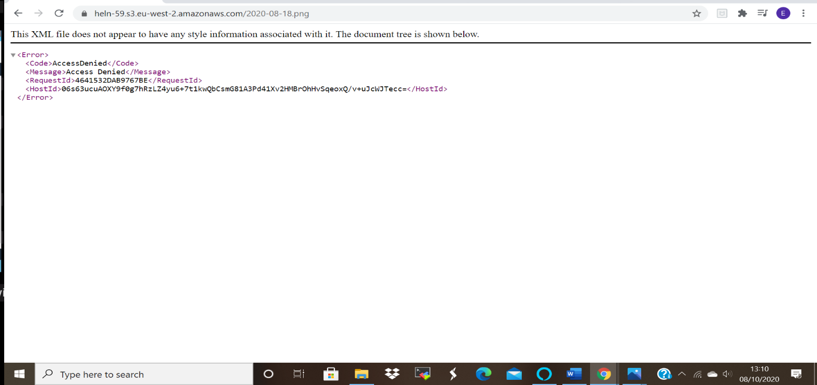

- Click on the bucket, then on permission to change the visibility of the file by unchecking the block public access box.
- Save and confirm. Then navigate to the overview tab and click on the object.
- Click on make public tub, then copy and paste the url to the browser and finally the object will be visible.
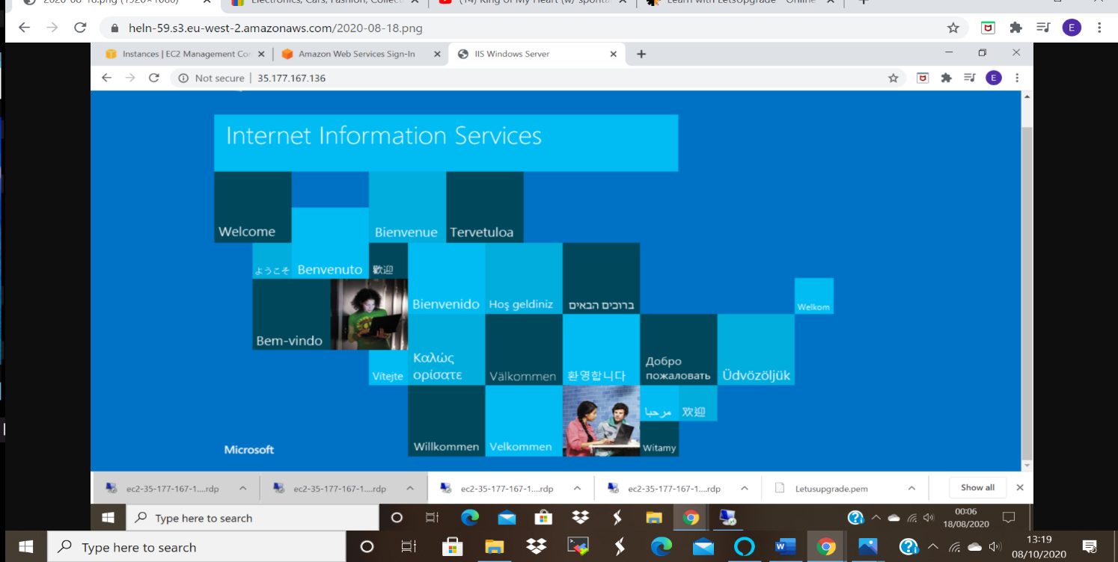
Static web hosting:
  - Click on Permissions, then Static Website Hosting
  - Check on the box; Use this bucket to host a web.
  - Create index and error .txt files and upload.
  - Make public and copy the endpoint to the browser .
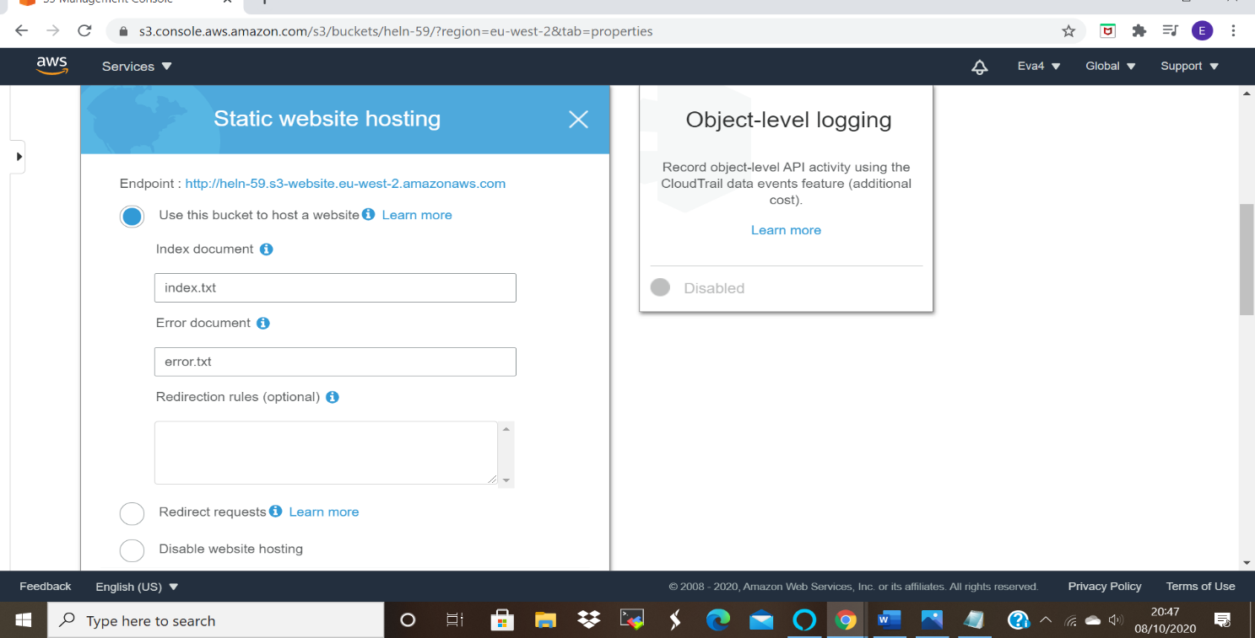

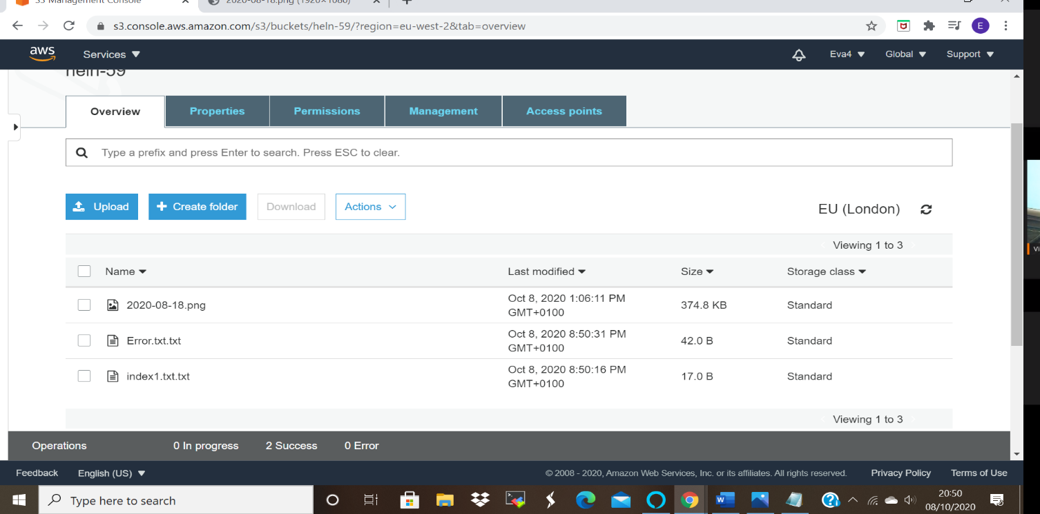

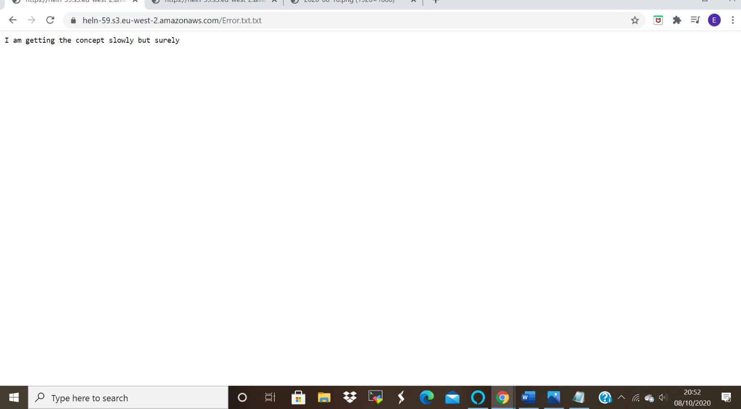

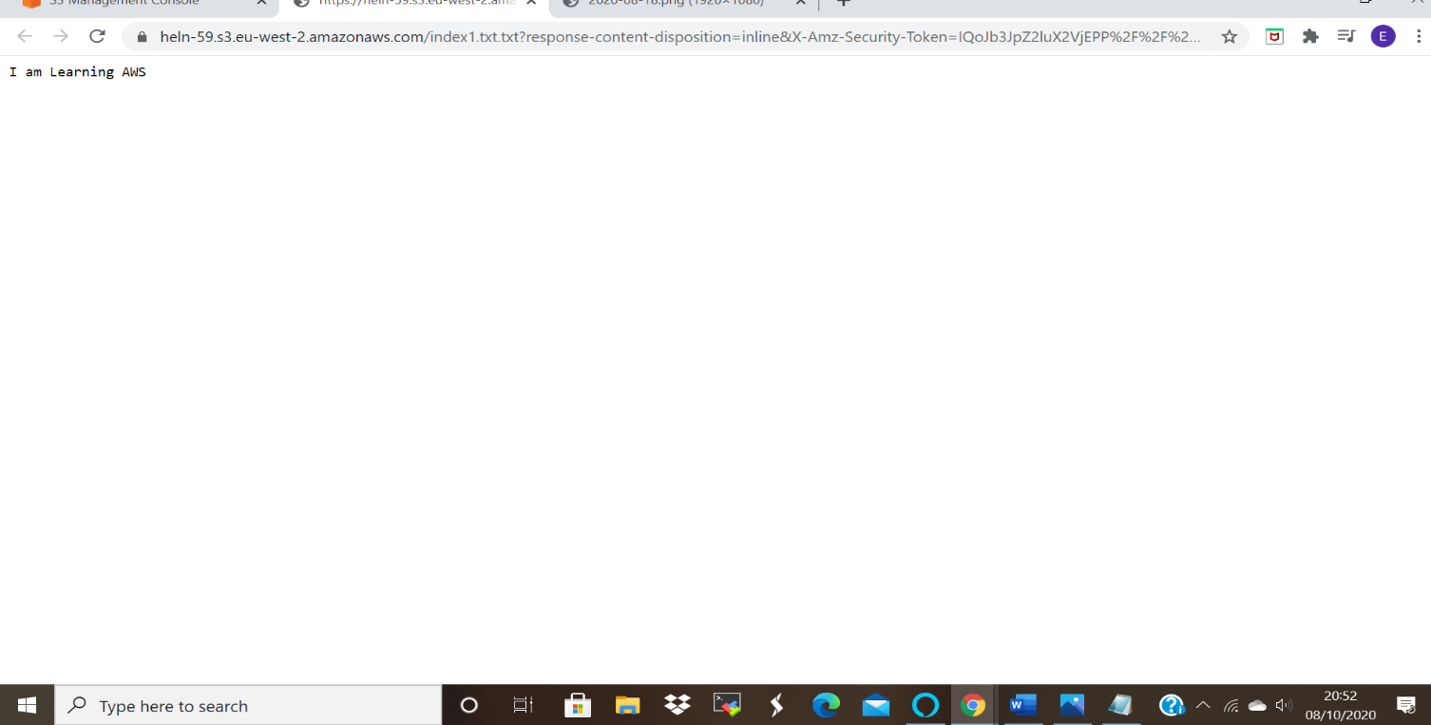

Versioning:
- Click on the bucket, then permission, then on the versioning tab ,
- Click enable versioning.
- Create a txt file and upload.
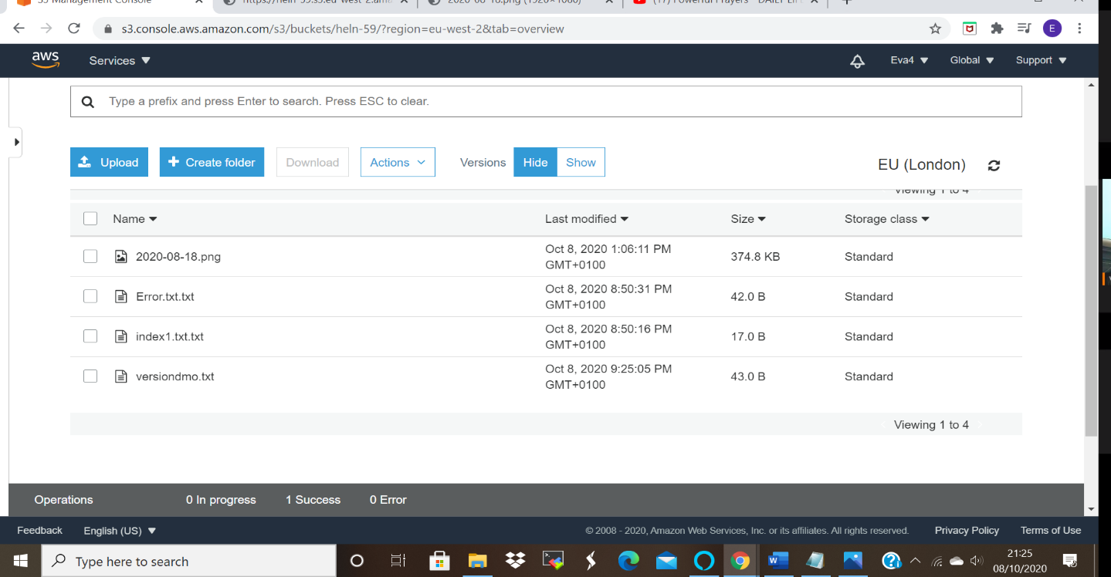

- Click show button to see the versions that have been created, you can adjust the content of the object and it will still be saved.

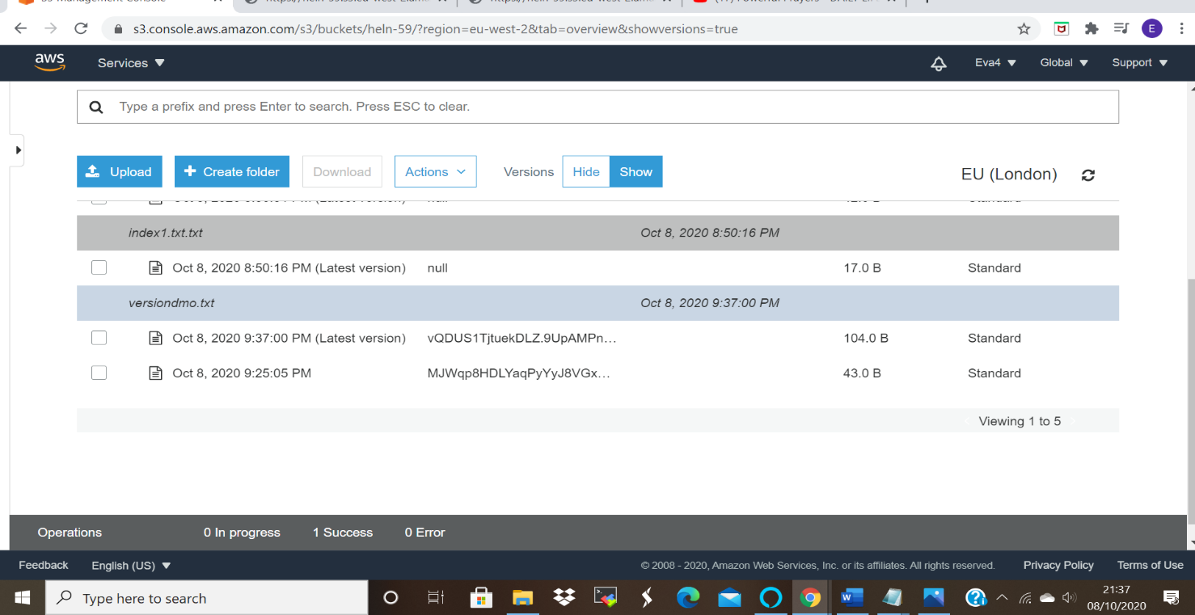

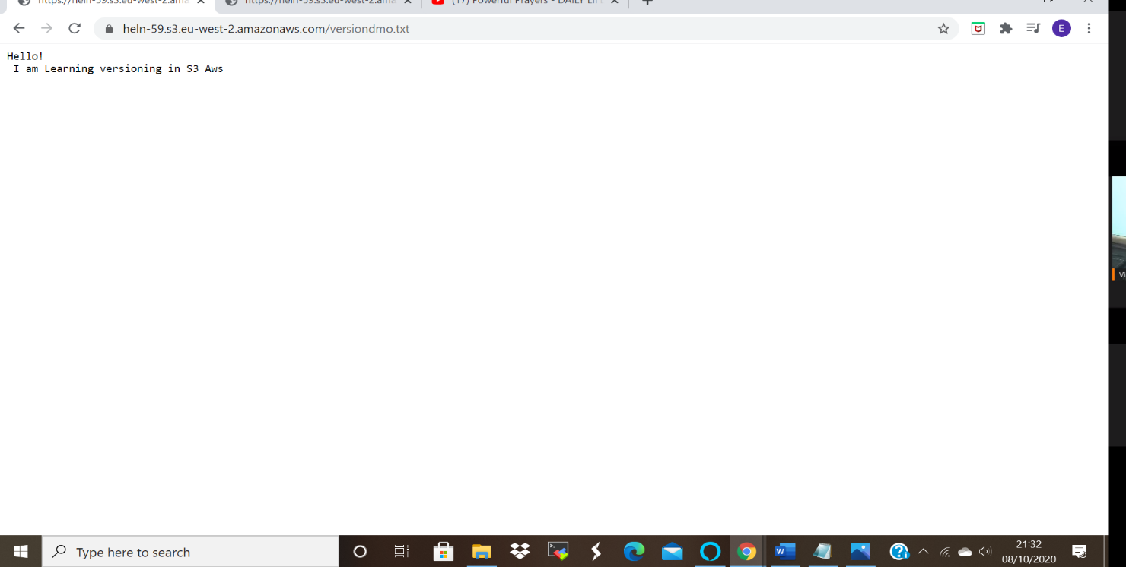
- In versioning when you delete the object it will be not permanently deleted instead Delete marker will show,
- And the file can be reuploaded from the the versions.

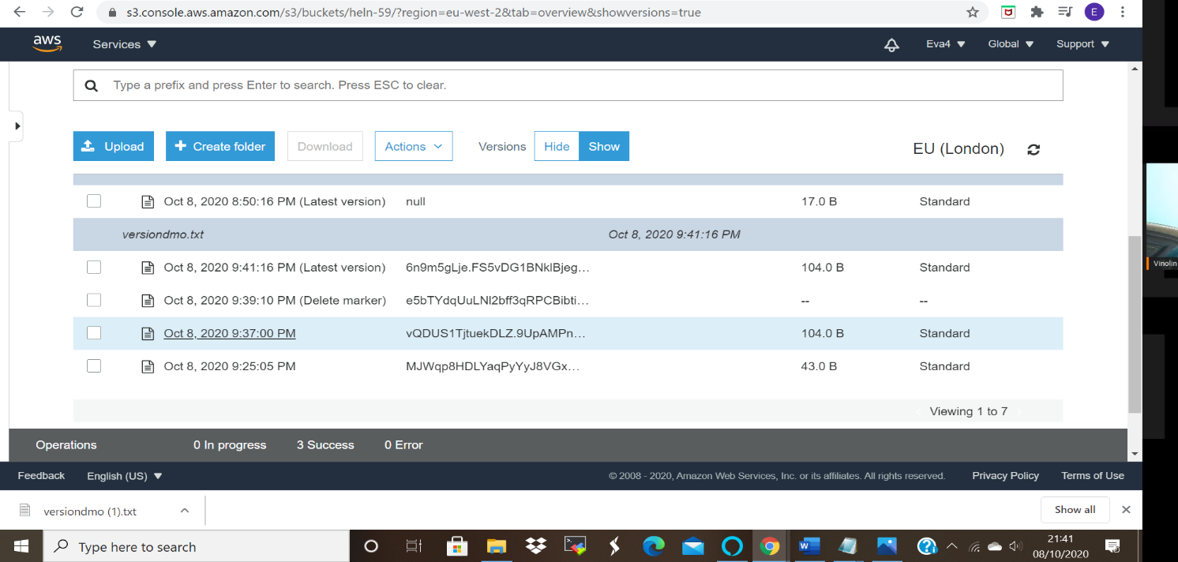

QUESTION 1:
Explain life cycle effects on instances: Stop, start, reboot, terminate-public IP, Private Ip, Applications installed.

- When an instance is stopped the Public IP is released while the private IP remains. That is will still be showing.
- When you restart an instance after stopping, it will be allocated a new Public IP while the private IP will remain the same.
- Rebooting does not influence both Public and Private Ips, the remain the same.
- Termination releases both public IP and deletes the private IP.
- The key pair and security groups remain the same, in stopping, starting and termination, until you manually delete them.
- When an Instance is terminated the Elastic IP gets detached from the instance back into the pool and can be reassociated to another instance, so we need to ensure that we manually delete it in order to avoid incurring charges. As it will be running even when the instance is terminated.

